|  |  |
| --- | --- |
| **Network Infrastructure**  Diploma in CSF / IT  Year 2 (2020/21) Semester 3 | Week 3 |
| Practical |
| Build and Configure a Routed Network – Static Routing | |

**Objectives**

At the end of this practical, student should be able to:

1. use a network simulation tool to build and test a routed network configuration;
2. set up a static routing table in routers; and
3. understand how router operates in a subnetted network.

**Introduction**

Packet Tracer is a stand-alone, simulation environment for networking novices to design, configure, and troubleshoot networks. Students first create a network topology using a drag-and-drop interface. The devices chosen may then be interconnected and configured via a GUI. Additionally, switches and routers may be configured by a limited simulated version of Cisco IOS.

**Activity 1**: **Building a Routed Network**

Set up an infrastructure of five subnets for the 3 routers network as shown in Figure 1.

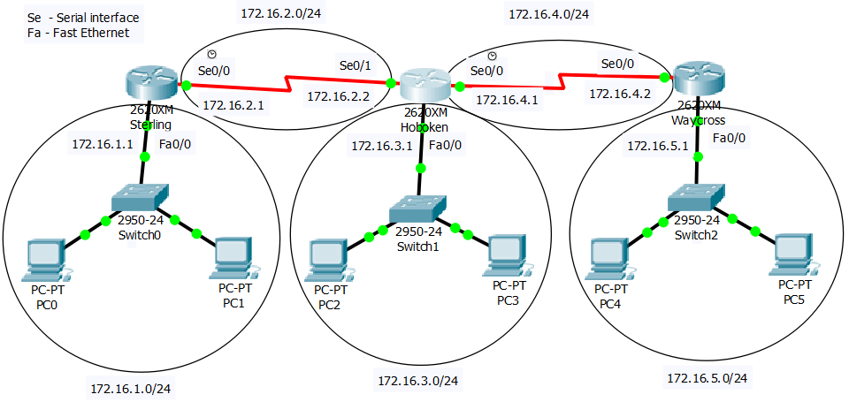

**Figure 1**

1. First add a serial interface to the router.

For router select Network Devices, router **2620XM model** (as shown) and drag it to the GUI.

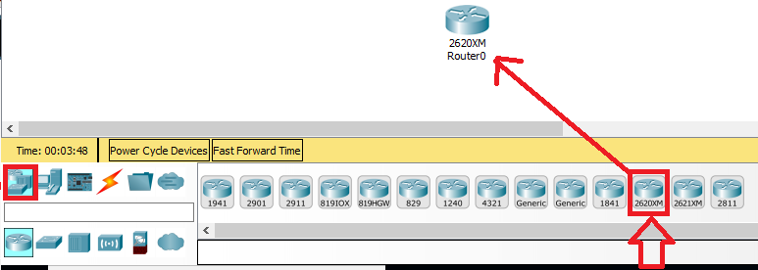

1. Click on the router. On **Physical Tab**, click on **Zoom In** and click on the **Power Switch** to switch it off.

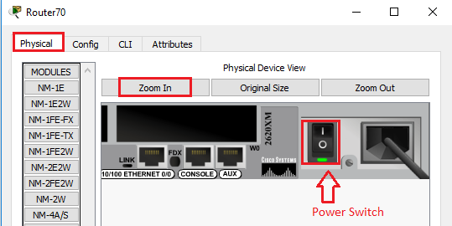

3. Select WIC-2T on the left under Modules, drag and drop it to empty slot on the router as shown.

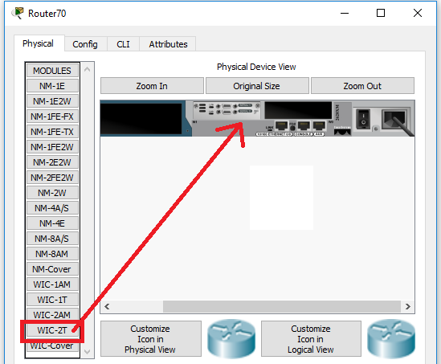

4. Turn on the power of the router.

1. Select the router and under File Menu, copy and paste to create 2 more routers (as shown).

Name the routers as Sterling, Hoboken and Waycross by clicking on their existing names (i.e. Router0) and typing in the new names.

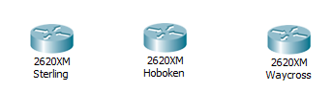

1. Drag and drop the switches and PCs. Connect them up using straight-through cables as shown below. Connect the switches to the routers with straight-through cables via the Fast Ethernet interfaces as well.

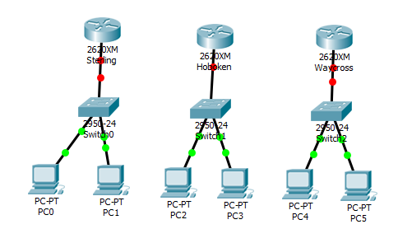

If you need to delete any components or connections, click  on the menu bar followed by the component or connection.



7. Connect the serial connections between routers.

Click on  followed by . (Serial DCE)

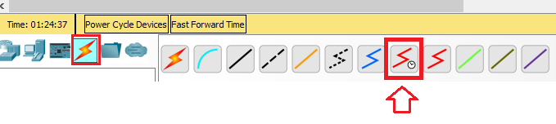

To connect, click on Sterling router and select **Serial0/0**.

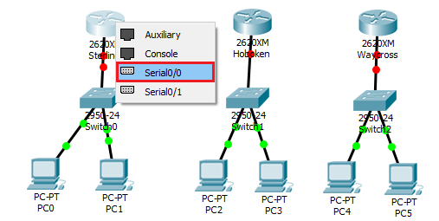

Next click on Hoboken router and select **Serial 0/1**.

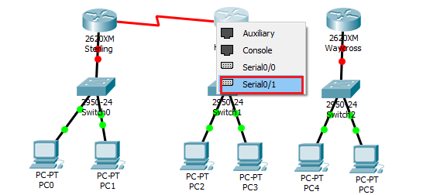

Make the same Serial DCE connection on Hoboken’s **Serial 0/0** interface (selected first) to Waycross’s **serial0/1 interface**.

Your configuration should look like the figure below:

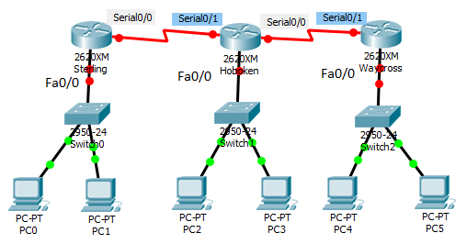

**Note: Check and ensure that the interfaces are chosen and connected correctly.**

1. Configure all the PCs with **appropriate IP addresses** , subnet mask and correct default gateway.

To configure, click on the **PC, Desktop tab** and select **IP Configuration**.

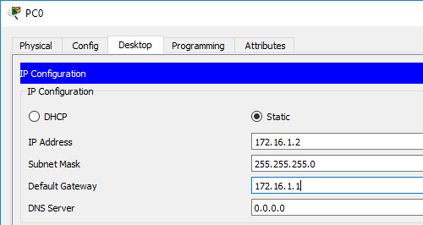

Write down the appropriate IP addresses of the PCs and their default gateway below

**PC0 and PC1**

**PC0: 172.16.1.2 PC1: 172.16.1.3 gateway:172.16.1.1**

**PC2 and PC3**

**PC2: 172.16.3.2 PC3: 172.16.3.3 gateway:172.16.3.1**

**PC4 and PC5**

**PC4: 172.16.5.2 PC5: 172.16.5.3 gateway:172.16.5.1**

**Activity 2: Routers Interface Configuration**

1. Set-up the interface configuration for Router Sterling.

To configure router using command line, click on Router Sterling, followed by CLI tab. Press return to start entering the commands.

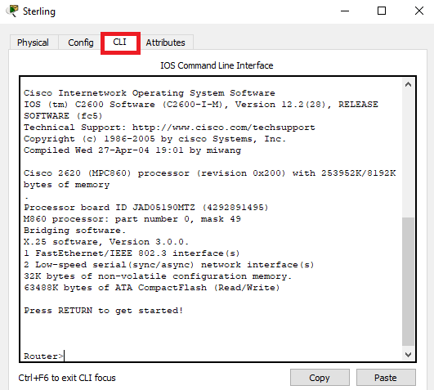

1. Type the following commands to set up fast Ethernet 0/0 for Router Sterling

Router>**enable**

Router# **configure terminal**

Router(config)#**hostname Sterling**

Sterling(config-if)#**interface fa0/0**

Sterling(config-if)#**ip address 172.16.1.1 255.255.255.0**

Sterling (config-if)#**no shutdown**

b) Repeat the setting for Serial 0/0 interface. (Ensure correct IP address is used). Write down the commands below:

Sterling(config-if)#**interface s0/0**

Sterling(config-if)#**ip address 172.16.2.1 255.255.255.0**

Sterling(config-if)#**clock rate 64000**

Sterling(config-if)#**no shutdown**

Note: clock rate command is only set on DCE serial interface. Sterling’s S0/0 interface and Hoboken’s S0/0 interfaces are DCE serial interfaces. You need to configure clock rate on these interfaces.

1. Enter “exit” twice to exit the Router Sterling configuration.
2. Configure the Router Hoboken’s interfaces similar to Router Sterling.

Hoboken

Configuration for Fast Ethernet

Router>enable

Router# configure terminal

Router(config)#hostname Hoboken

Hoboken (config-if)#interface fa0/0

Hoboken (config-if)#ip address 172.16.3.1 255.255.255.0

Hoboken (config-if)#no shutdown

Hoboken

Configuration for Serial Interfaces

Hoboken (config-if)#interface s0/0

Hoboken (config-if)#ip address 172.16.4.1 255.255.255.0

Hoboken (config-if)#clock rate 64000

Hoboken (config-if)#no shutdown

Hoboken (config-if)#interface s0/1

Hoboken (config-if)#ip address 172.16.2.2 255.255.255.0

Hoboken (config-if)#no shutdown

1. Similarly, configure the Router Waycross’ interfaces.

Router(config)#**hostname Waycross**

Waycross(config-if)#interface fa0/0

Waycross(config-if)#ip address 172.16.5.1 255.255.255.0

Waycross(config-if)#no shutdown

Hoboken

Configuration for Serial Interfaces

Hoboken (config-if)#interface s0/0

Hoboken (config-if)#ip address 172.16.4.2 255.255.255.0

Hoboken (config-if)#no shutdown

Note:

* To undo any command, put a **no** in front of the typed command. For example, to undo the IP address just type:
  + - **no ip address 172.16.5.1 255.255.255.0**
* Use #**show run** command to view the running configuration of the router. This command is useful to find out what commands have already been configured on the router.

2. Check interface configuration for all 3 routers. You should have the similar output as shown.

*Sterling#****sh ip interface brief***

*Interface IP-Address OK? Method Status Protocol*

*FastEthernet0/0 172.16.1.1 YES manual up up*

*Serial0/0 172.16.2.1 YES manual up up*

*Hoboken#****sh ip interface brief***

*Interface IP-Address OK? Method Status Protocol*

*FastEthernet0/0 172.16.3.1 YES manual up up*

*Serial0/1 172.16.2.2 YES manual up up*

*Serial0/0 172.16.4.1 YES manual up up*

*Waycross#****sh ip interface brief***

*Interface IP-Address OK? Method Status Protocol*

*FastEthernet0/0 172.16.5.1 YES manual up up*

*Serial0/1 172.16.4.2 YES manual up up*

If not, check the cables connections and verify the commands.

3. Before static route is setup, check the routing tables in the 3 routers:

*Sterling#****show ip route***

*Codes: C - connected, S - static, I - IGRP, R - RIP, M - mobile, B - BGP*

*D - EIGRP, EX - EIGRP external, O - OSPF, IA - OSPF inter area*

*N1 - OSPF NSSA external type 1, N2 - OSPF NSSA external type 2*

*E1 - OSPF external type 1, E2 - OSPF external type 2, E - EGP*

*i - IS-IS, L1 - IS-IS level-1, L2 - IS-IS level-2, ia - IS-IS inter area*

*\* - candidate default, U - per-user static route, o - ODR*

*P - periodic downloaded static route*

*Gateway of last resort is not set*

*172.16.0.0/16 is subnetted, 2 subnets*

*C 172.16.1.0/24 is directly connected, FastEthernet0/0*

*C 172.16.2.0/24 is directly connected, Serial0/0*

*Hoboken#****show ip route***

*172.16.0.0/16 is subnetted, 3 subnets*

*C 172.16.2.0/24 is directly connected, Serial0/1*

*C 172.16.3.0/24 is directly connected, FastEthernet0/0*

*C 172.16.4.0/24 is directly connected, Serial0/0*

*Waycross#****show ip route***

*172.16.0.0/16 is subnetted, 2 subnets*

*C 172.16.4.0/24 is directly connected, Serial0/1*

*C 172.16.5.0/24 is directly connected, FastEthernet0/0*

All static routes will be marked with an S on the left most column in the routing table.

Do you see any static routes shown in the routing tables? No

4. Test the connectivity from router Sterling to the router Waycross Fast Ethernet Interface address 172.16.5.1. Is the connectivity test successful? No

5. Setup the static routes for the routers. The commands for Sterling are shown below. Write down the commands for the other 2 routers.

*Router Sterling*

*Sterling#****config t***

*Sterling(config)#****ip route 172.16.3.0 255.255.255.0 172.16.2.2***

*Sterling(config)#****ip route 172.16.4.0 255.255.255.0 172.16.2.2***

*Sterling(config)#****ip route 172.16.5.0 255.255.255.0 172.16.2.2***

*Sterling (config)#****exit***

*Router Hoboken*

Hoboken#config t

Hoboken(config)#ip route 172.16.5.0 255.255.255.0 s0/0

Hoboken(config)#ip route 172.16.1.0 255.255.255.0 s0/1

*Router Waycross*

*Waycross#config t*

*Waycross(config)#ip route 172.16.3.0 255.255.255.0 s0/0*

*Waycross(config)#ip route 172.16.2.0 255.255.255.0 s0/0*

*Waycross(config)#ip route 172.16.1.0 255.255.255.0 s0/0*

6. Check routing table for all the 3 routers. You should see the following routes.

*Sterling#****show ip route***

*Codes: C - connected, S - static, I - IGRP, R - RIP, M - mobile, B - BGP*

*D - EIGRP, EX - EIGRP external, O - OSPF, IA - OSPF inter area*

*N1 - OSPF NSSA external type 1, N2 - OSPF NSSA external type 2*

*E1 - OSPF external type 1, E2 - OSPF external type 2, E - EGP*

*i - IS-IS, L1 - IS-IS level-1, L2 - IS-IS level-2, ia - IS-IS inter area*

*\* - candidate default, U - per-user static route, o - ODR*

*P - periodic downloaded static route*

*Gateway of last resort is not set*

*172.16.0.0/16 is subnetted, 5 subnets*

*C 172.16.1.0/24 is directly connected, FastEthernet0/0*

*C 172.16.2.0/24 is directly connected, Serial0/0*

*S 172.16.3.0/24 [1/0] via 172.16.2.2*

*S 172.16.4.0/24 [1/0] via 172.16.2.2*

*S 172.16.5.0/24 [1/0] via 172.16.2.2*

*Hoboken#****show ip route***

*Codes: C - connected, S - static, I - IGRP, R - RIP, M - mobile, B - BGP*

*D - EIGRP, EX - EIGRP external, O - OSPF, IA - OSPF inter area*

*N1 - OSPF NSSA external type 1, N2 - OSPF NSSA external type 2*

*E1 - OSPF external type 1, E2 - OSPF external type 2, E - EGP*

*i - IS-IS, L1 - IS-IS level-1, L2 - IS-IS level-2, ia - IS-IS inter area*

*\* - candidate default, U - per-user static route, o - ODR*

*P - periodic downloaded static route*

*Gateway of last resort is not set*

*172.16.0.0/16 is subnetted, 5 subnets*

*S 172.16.1.0/24 [1/0] via 172.16.2.1*

*C 172.16.2.0/24 is directly connected, Serial0/0*

*C 172.16.3.0/24 is directly connected, FastEthernet0/0*

*C 172.16.4.0/24 is directly connected, Serial0/1*

*S 172.16.5.0/24 [1/0] via 172.16.4.2*

*Waycross#****sh ip route***

*Codes: C - connected, S - static, I - IGRP, R - RIP, M - mobile, B - BGP*

*D - EIGRP, EX - EIGRP external, O - OSPF, IA - OSPF inter area*

*N1 - OSPF NSSA external type 1, N2 - OSPF NSSA external type 2*

*E1 - OSPF external type 1, E2 - OSPF external type 2, E - EGP*

*i - IS-IS, L1 - IS-IS level-1, L2 - IS-IS level-2, ia - IS-IS inter area*

*\* - candidate default, U - per-user static route, o - ODR*

*P - periodic downloaded static route*

*Gateway of last resort is not set*

*172.16.0.0/24 is subnetted, 5 subnets*

*S 172.16.1.0 [1/0] via 172.16.4.1*

*S 172.16.2.0 [1/0] via 172.16.4.1*

*S 172.16.3.0 [1/0] via 172.16.4.1*

*C 172.16.4.0 is directly connected, Serial0/1*

*C 172.16.5.0 is directly connected, FastEthernet0/0*

From router Hoboken, what is the next hop address to reach router Sterling Fast Ethernet network 172.16.1.0? 172.16.2.1

_____________________________

From router Hoboken, what is the next hop address to reach router Waycross Fast Ethernet network 172.16.5.0? 172.16.4.2

_______________________________

7. Confirm network connection by using the “ping” command. At Router Sterling, ping the Fast Ethernet interface at Router Waycross to confirm the network configuration.

*Sterling#****ping 172.16.5.1***

*Type escape sequence to abort.*

*Sending 5, 100-byte ICMP Echos to 172.16.5.1, timeout is 2 seconds:*

*!!!!!*

*Success rate is 100 percent (5/5), round-trip min/avg/max = 5/5/6 ms*

*Sterling#*

8. Use ping command to check connectivity from PC0 to PC5 (check the configured IP address of PC5 and PC1) and vice versa.

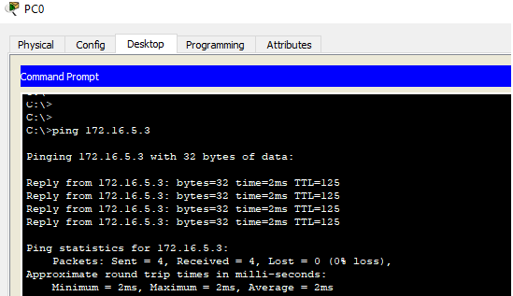

9. Trace the packet from PC0 to PC5 using tracert command. A successful command will show that the packets passing 3 routers and then to the destination.

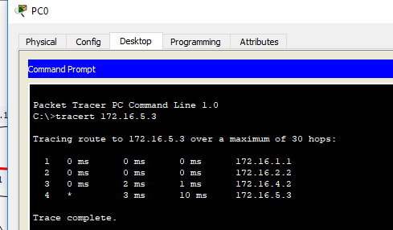

**Activity 3: Simulation**

1. Use the simulation mode to show how packets travel from a PC0 to PC5.
2. Select View menu and click on “Simulation” mode.
3. The simulation panel on the right side appears. Right click on the top of simulation panel bar and select **PDU List Window.**

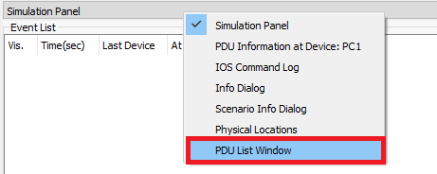

The PDU List Window appears.

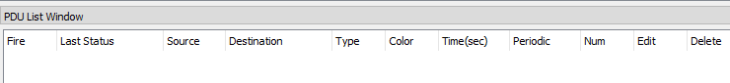

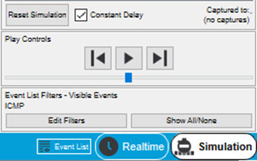

1. Click on Edit Filters and checked only ICMP.

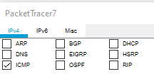

1. Add a packet route from, say, PC0 to PC5.

Do this by selecting the  icon on the right.

Then just click on **PC0** (envelope icon appears) and then click on **PC5**. The following appears on the PDU List Window:



6. To view the simulation, click the Play button.

You will see the animation movie as shown.

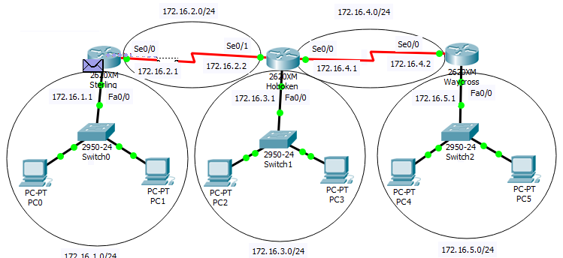

After the packet had reached PC5, it will travel back to PC0. Show the animation clip to your lecturer for verification.

If needed, click on Reset Simulation to reset the animation.